OUT REACH DRAMA TO KITUMBA ORGANIZED BY PEER EDUCATORS OF MPANGA SS.
The drama was both educative and entertaining. The coordinator was invited to give a health talk about HIV and take photos. According to my observation, the students demonstrated a high level of leadership and organization. The drama was entirely organized by them, after being granted acceptance by the administration of Kitumba ss. RHU transported them on their vehicle, including the public address system.
The function started at 3.30Pm with an opening prayer and mimes. Later a play about HIV followed. This was organized by the peer educators of Kitumba ss. The play was about girls who don’t listen to the advice of their parents but instead follow the ill advice of their bad peer groups. They go dancing in discos together with their boyfriends but at the end of it both girls are in trouble. One of them is HIV positive, suffers and dies and the other gets unwanted pregnancy and dies while aborting. It at this critical moment that learning took place. The cheering audience was covered with silence at this level of the play, an indicator that they were internalizing the outcomes of irresponsible sexual behavior. A song cautioning the audience about HIV followed and was sang by all the peer educators of Kitumba ss.
After the play, the coordinator, Denis gave a health talk about HIV, advising the audience to be very careful not to get HIV because getting HIV would sabotage their future dreams and expectations. He emphasized abstinence and also articulated other preventive strategies such as condom use, safe male circumcision and PEP
The remaining session was entertainment in form of mimes, creatives and skits by peer educators of Mpanga ss.

CASE STUDY
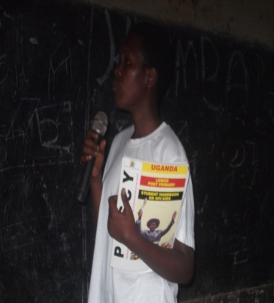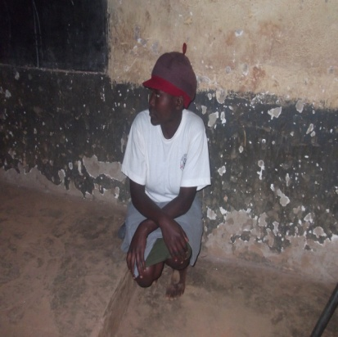

Bayaya Emaculate and Tusiime Doreen acting a play about AIDs
This case study explores three peer educators whose work is impressive. These are Bagaya Emaculate, the chairperson peer education Kitumba ss. This is a senior four students who has been in the club since senior one. She reminded the coordinator of the training that was conducted when she was still in senior one that gave her the morale and motivation to be a very active peer educator. She carries PIASY book which she uses to go from one class to another sensitizing students. Every Friday, their club conducts an educative drama show. According to her, their peer educators need a comprehensive training in reproductive health issues. She, together with her friend, Tusiime Doreen one of the executive members were the main organizers and main actresses of the above said impressive and educative play.
The third is Saturday Enoch senior six, the speaker of peer education club Mpanga ss. He was the main organizer of the outreach to Kitumba. He officially wrote to the administration and the peer educators on Mpanga ss, requesting to hold a drama there. When the opportunity was granted, he approached RHU manager and requested to be given a vehicle to transport the peer educators and the public address system. This demonstrated a high level of mobilization, organization and leadership.

In respect to the agreement that was reached to identify peer educators capabilities and rank them in form of junior for those who are still lacking in peer leadership and knowledge of reproductive health issues and senior for those are have a relatively high level of leadership and are more knowledge about reproductive health issues, I therefore recommend that these individuals be promoted to the rank of senior peer educators.

